# Benefits of 50% cycling

### 1. efficient

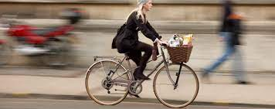

Journeys are often quicker by bike, also allowing shopping and stopping en route.

### 2. health



Cycling improves mental and physical health 33% .

### 3. Pollution and noise

50% reduced, with less disease from particulates and noise.

### 

**£**

### 4. Cheap

Cycling is cheap. Road maintenance will be cheaper with less traffic.

### 5. Highly recommended



World Health Organization, recommends cycling, as in many European towns and cities.

### 6 Bus flow



Traffic is reduced so buses will be less stuck in traffic jams. Buses will be quicker for those not walking or cycling.

### 7 Popular



Many more people want to cycle but are currently too scared, due to the amount and speed of traffic, often very close to bicycles.

### 8. Youth engagement

Reduces screen use and improves social skills among young people. Young people will gain most from this independence.



### 9. Local economy

1. Cycling encourages people to shop nd go out locally, boosting local spending. Cycling reduces absenteeism.
2. And more pleasant (less traffic) surroundings lead to more jobs being created.

### 10. Community benefits

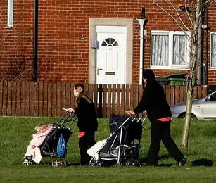

Poorer communities are more harmed by traffic, as people live closer to busy roads. So poorer communities benefit significantly with more cycling

Because people go out more to meet or volunteer, lives are enriched,

### 11 Net Zero targets

It will be impossible to reach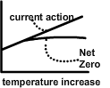 council and government Net Zero targets unless we reduce car use.   
Without reaching Net Zero, we will get ever warmer, with forest fires in the South downs, Littlehampton underwater, poor harvests, and more forced migration from disaster areas.

### 12 Climate



80% of us are worried about the impending climate disaster, and 90% of us want more government and council action.

# Objections

The commonest objection is that cycling takes longer than car travel. Shorter journey times will not increase. Longer journeys can be made on public transport which should be more efficient.

**Older people** will often be able to use electric bikes or tricycles.

**Those who cant cycle** will have improved public transport.

**Disabled people** should have access to a special taxi service.

**Young children** can travel as passengers on modified bicycles, and the network needs to be safe for children.

**Employment laws** will need changing to allow parents time to take younger children to school on their bike or walking, and then to travel on to work.

**Unsafe** Adults not feeling safe on a 2 wheeled bike should be helped to ride tricycles, which could be electric. And many will benefit from cycle training.

# Infrastructure.

50% cycling will need a cycling network as in European cities, costing about £2m/km.

This includes paths and cycle lanes and pedestrian and cycle friendly traffic lights, and road engineering, and trees, to slow down traffic.

Public transport improvements are essential, included in this sum.

As with all roads maintenance is needed. But will less traffic, maintenance costs will be much lower.

However, improved public transport and travel for people with disabilities with need ongoing subsidies.

The cycle network should be safe for an 11y old to travel independently, and an even younger child to cycle safely with an older cyclist supervising.

Most junctions will need re-engineering. And all speeds limited to 20mph.

# 10 year plan

This is a 10 year plan, as such a change has to be gradual, with the first stage 20sPlenty, that is slow speeds urban areas.

|  |  |
| --- | --- |
| Arterial Roads | |
| Arterial roads must be modified to include effective bus lanes, as well as bicycle lanes.  This must mean less road space for cars. |  |

50 in 10

**50% cycling in 10y in urban areas of West Sussex & UK**

**Why**

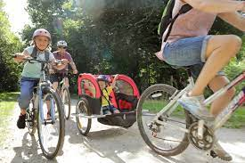

This leaflet discusses the benefits of 50% cycling. Increasing cycling is recommended by the World Health Organization (WHO). It has been found to help communities thrive in a time of increasing and faster traffic and climate change.

(The benefit are much greater than 20s Plenty. However, 20s Plenty (see our separate leaflet) would be the first stage.)

The scientific papers and research supporting this plan is here:  
http://www.carbonfootprintlabelling.org.uk/20splentyreferences.html

(Illustration above, World Health Organisation)

This leaflet, http://www.carbonfootprintlabelling.org.uk/50in10.html